**William Hemmant (24 November 1837 – 20 September 1916)**

**Early Years:** William Hemmant was born in Kirkgate, Leeds, to Thomas and Isabella on 24 November 1837.

His father Thomas was born into a farming family in 1801, in the village of Whittlesey, in Cambridgeshire. By 1829, he had left his home town, and was established as a draper in Briggate, Leeds. In 1835 he married Isabella Richmond and William was born on Friday 24 November 1837. [1]

William will have learned a lot about the drapery trade as a young man. He worked as a draper in London before departing Gravesend in 1859, aged 21, to make his fortune as a goldseeker. He arrived at Melbourne in June 1859, and he briefly worked as miner in Ballarat during the gold rush. There he met Alexander Stewart, with whom he would forge a long lasting business relationship.

**Stewart and Hemmant:** The gold rush had clearly not tempted William to stay. Stewart and Hemmant went into business together, and in March 1860, just 9 months after Hemmant arrived in Australia, the Stewart and Hemmant general drapery store opened in Brisbane, on the corner of Queen and Albert Streets. Disaster struck with the Great Fire of Brisbane in 1864. Believed to have started in the Stewart and Hemmant premises, it destroyed most of the wooden buildings on the Queen St block, and their store was burnt to the ground.

Nonetheless, the two partners successfully re-established their department store and clothing manufacturing business on nearby Queen and Adelaide Streets.

After completing the task of rebuilding, Hemmant, aged 28, left for England in November 1865 to marry Lucy Ground. Lucy’s father, Daniel, was a neighbour to William’s grandfather in the hamlet of Eldernell, outside Whittlesey, and William’s father Thomas was also born in Eldernell. It is likely that William and Lucy knew each other before William set off for Australia. It is possible they were also distant cousins.

They married at Coates, Cambridgeshire on 20 September 1866, and William returned to Queensland early the next year, leaving his wife to follow.

**Eldernell:** In 1869 he built Eldernell house, on a 4 acre plot in a semi-rural location, overlooking Hamilton and the Brisbane river. Hemmant did not lack ambition; unusually it was built of stone. Designed by James Cowlishaw, a prominent Brisbane architect, in the Victorian style, it had a steep pitched gable roof and tall medieval chimneys, gabled porch and Gothic archways. [2]

‘Eldernell’ was named after the hamlet outside Whittlesea in Cambridgeshire, the birthplace of both his wife and father. Over the years, Lucy gave birth to 5 children in Brisbane, at least 3 of them at Eldernell.

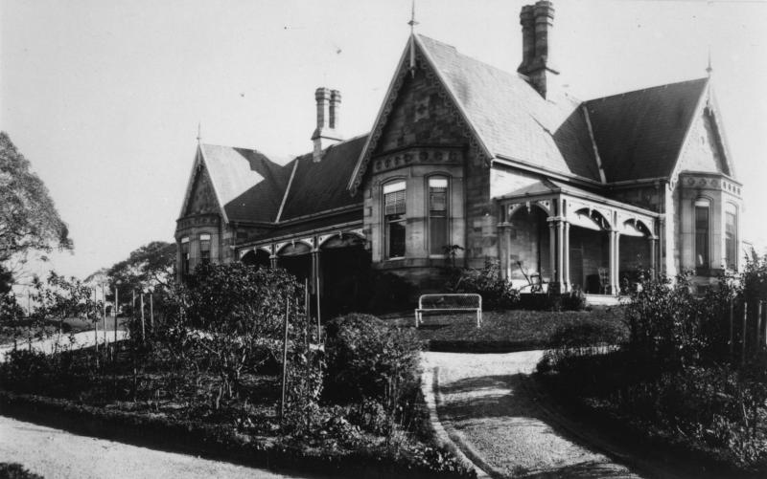

Part of a panorama of the house and garden of Eldernell, Hamilton, Brisbane', John Oxley Library, State Library of Queensland

The Stewart and Hemmant business sold draper’s wares including fabrics, clothing and accessories and occasionally sundries imported from England. Christmas specials included storage goods, eau de cologne and other toiletries. The success of the business led Stewart and Hemmant to open branches in Rockhampton, Sydney and Melbourne, and to expand their Queen Street premises in 1874.

In common with many other businesses, Stewart & Hemmant issued one penny tokens, to compensate for the shortage of small change in circulation in Brisbane. Surprisingly valuable, examples from 1863 are held in London and Melbourne museum collections.

In the mid-1870s, Stewart and Hemmant’s business changed its focus from retail to wholesale. [3] The retail business, which was described in the Brisbane Courier as ‘one of the oldest and most extensive retail drapery businesses in this colony’, was sold 1876, with Stewart and Hemmant instead importing goods as warehousemen.[4]

Hemmant was taking an increasing active role in politics, and he left the day-to-day running of the business in 1871, taking a particular interest in shipping and labour legislation.

**Queensland Politics**:

Early on, he had led an attack on the Brisbane City Council for financial mismanagement and was elected an alderman in 1868, but in August 1870 he lost South Brisbane. He joined the committee of a political reform association pledged to defeat the squatting oligarchy. These were typically landed British gentry who had occupied large tracts of Crown Lands without license and established large pastoral holdings. Their wealth and power allowed them to dominate local politics in the new colony, which had only been chartered in 1859. With its backing Hemmant won a by-election for East Moreton in November 1871.

Hemmant shared the seat of East Moreton with a young Irish journalist and lawyer, Robert Travers Atkin, who had been elected the year before. Atkin had liberal values that chimed with Hemmant’s, but in March 1872, Atkin had to resign his seat due to ill health, allowing Samuel Griffith to stand in his place, who went on to enjoy a brilliant political career. Atkin was 4 years younger than Hemmant, with a young family, and William cared for his friend and colleague Robert Atkin until his early death in Sandgate, in May 1872. [5]

Hemmant successfully contested the seat of Bulimba in 1873 and was the member from Nov 1873 to Nov 1876. He also served as Colonial Treasurer from January 1874 to June 1876. His tariff policies introduced moderate protection in Queensland. He is also credited with producing four badges as candidates for the Flag of Queensland, from which the current badge, a crowned Maltese cross, was chosen.

**Interests in England**

In June 1876 Hemmant resigned as Treasurer and left politics. He returned to England in 1876, and his family settled in Blackheath, London, where another 7 children were born to Lucy. The youngest, Maurice, was born in 1887, 20 years younger than Lucy, his eldest sister.

When he returned to England he acted as resident partner for Stewart and Hemmant, but continued to correspond with Samuel Griffith and served as commissioner for Queensland at several exhibitions in Europe. Early in 1880 he wrote to Griffith alleging scandals in the purchase of railway lines and in contracts for the conveyance of immigrants. Inquiry by a select committee and a royal commission found little substance in the allegations but, when Griffith became premier, Hemmant acted as agent-general in 1885 and represented Queensland at the International Postal Union Congress.

William Hemmant retained his interest in Stewart and Hemmant until the partnership was officially dissolved in August 1893. Hemmant sold out but continued to serve the firm as a commission agent until 1900 whilst devoting himself mainly to the Australian Joint Stock Bank.

As an investor and client of the Australian Joint Stock Bank, Hemmant was appointed to its London board in 1876. In 1897 he chaired the London meeting which accepted a reconstruction scheme and in 1911 was commended for his service in transforming the Australian Joint Stock Bank into the Australian Bank of Commerce. He was a director of the new bank until he died on 20 September 1916.

**Atkin Connections:** In about 1888, young Dick Atkin, the son of his old parliamentary colleague, Robert Atkin, visited William Hemmant at Bulimba. He met and fell in love with Hemmant’s eldest daughter, Lucy. Lucy had also been born in Brisbane, just a few days before Dick, and a short distance away at North Quay.

Dick was still at Magdalen College, Oxford, so despite their engagement, they were unable to marry. Dick Atkin was called to the bar by Gray’s Inn in 1891, and Hemmant introduced Dick Atkin to a local solicitor, Norman Herbert Smith, who had just started out as a solicitor in the City of London. Smith gave Atkin his first brief, and 3 years later, in 1893, Atkin was earning enough to marry Lucy. (As an aside, Herbert Smith became one of the leading law firms in London, and now has a global presence.)

**Bulimba:** In 1891 William commissioned ‘Bulimba’ in Sevenoaks, an unusual name, after the Brisbane district he served as a member. A grand 22 room mansion set in about 20 acres on Kippington Lane, adjacent to St Mary’s Church. The build specification described in ‘The Builder’ magazine includes marble flooring, marble baths, carved oak panelling, bespoke door furniture and extensive plasterwork, stained glass and warm air heating, amongst all possible modern comforts. [6] [7]

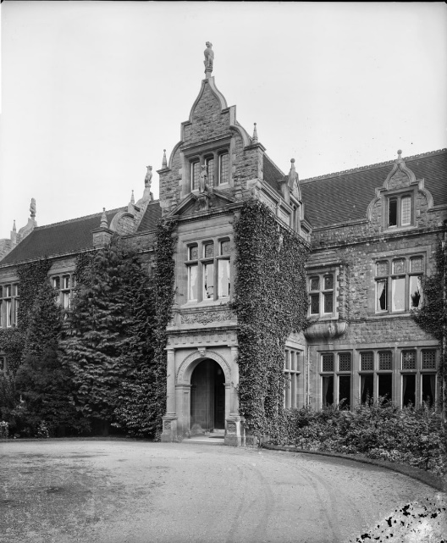

Entrance front, and the hall, Bulimba, Oct 1916. Historic England archives

In 1893, the new house hosted Dick and Lucy’s wedding.

William’s wife, Lucy Hemmant, died relatively young, in 1897, aged 59. William lived a further 19 years.

The 1911 household census lists 8 female servants and a reader[8], presumably for William. The male servants were separately accounted for. After William’s death, the house was put up for sale in 1917. Like many large houses in the post-war period, it was expensive to run, with a raft of scarce servants required, and was eventually demolished in 1933. Some of the stone and brick was reused to build one of the houses at Sevenoaks School. The stable block however, still stands.

By the time he built Bulimba, near Sevenoaks, he was evidently already a very wealthy man. When he died, in his will he left £92k, worth about £10Mn in 2024. Not bad for the son of a draper!

William Hemmant was a quintessential Victorian success story. An entrepreneurial man, with strong commitment to fiscal prudence he railed against any perceived financial mismanagement. He produced a large family, lived in grand style and lived to the good age of 78.

As a lasting reminder in Brisbane, the suburb of Hemmant is named after him.

References:

1. Genealogical data: https://family.adxe.uk/
2. About Eldernell, Brisbane: https://heritage.brisbane.qld.gov.au/heritage-places/822, information about the house he built overlooking Brisbane
3. Stewart and Hemmant factories in Brisbane. The citation is a really interesting insight into the fortunes of the Brisbane clothing industry: https://heritage.brisbane.qld.gov.au/heritage-places/732
4. About Stewart and Hemmant factories in Brisbane: https://heritage.brisbane.qld.gov.au/heritage-places/732
5. Peter Applegarth on the connection between Atkin and Hemmant. https://www.hearsay.org.au/who-inspired-lord-atkin/
6. Images of Bulimba - https://historicengland.org.uk/images-books/photos/results/?searchType=HE+Archive+New&search=bulimba
7. About Bulimba, Kippington, Kent: Extract from ‘The Builder 1891, listing the high specification of the building.. https://manchestervictorianarchitects.org.uk/buildings/bulimba-kippington-sevenoaks
8. The census list for 1911 is shown below. The male servants lived in the adjacent stable block.

   |  |  |  |  |  |  |  |  |  |
   | --- | --- | --- | --- | --- | --- | --- | --- | --- |
   | **1911 Census for England and Wales. Bulimba, Sevenoaks, Kent** | | | | | | |  |  |
   | **First Name** | **Last Name** | **Relationship** | **Marital Status** | **Sex** | **Age** | **Birth Year** | **Occupation** | **Birth Place** |
   | William | Hemmant | Head | Widower | Male | 73 | 1838 | Private means | Leeds, Yorkshire |
   | Ada | Hemmant | Daughter | Single | Female | 39 | 1872 | — | Eldernell, Queensland |
   | Mary | Hemmant | Daughter | Single | Female | 32 | 1879 | — | Ealing, Middlesex |
   | George | Hemmant | Son | Single | Male | 30 | 1881 | Civil servant | Blackheath, Kent |
   | Eric Ayton | Dickson | Visitor | Single | Male | 35 | 1876 | Civil servant | Marmondsworth, Middlesex |
   | Annie Maria | Ewens | Servant | Single | Female | 36 | 1875 | Servant domestic | Haywards Heath, Sussex |
   | Isabel Jane | Harvey | Servant | Single | Female | 25 | 1886 | Servant domestic | Sevenoaks Weals, Kent |
   | Annie Amelia | Williams | Servant | Single | Female | 38 | 1873 | Servant domestic | Basaleg, Monmouthshire |
   | Eleanor | Medhurst | Servant | Single | Female | 21 | 1890 | Servant domestic | Murston, Kent |
   | Ethel May | Seagrove | Servant | Single | Female | 21 | 1890 | Servant domestic | Reading, Berkshire |
   | Emma Elizabeth | Rodwell | Servant | Single | Female | 22 | 1889 | Servant domestic | Belvedere, Kent |
   | Louisa Grace | Gatland | Servant | Single | Female | 17 | 1894 | Servant domestic | Homerton, London |
   | Ann | Barret | — | Single | Female | 17 | 1894 | Servant domestic | Overton, Wiltshire |
   | Ethel | Elwell | — | Single | Female | 34 | 1877 | Reader | Hamsted, Stratfordshire |

  